Student Enrollment & Course Management System (SECMS)Description
PROJECT TITLE : Farm Management System (FMS)
TEAM ID : SWTID-2026-8757
Team Leader : NAVEEN KUMAR A
NM ID : 6215116EE51A15AB0B24D183DD98C06A

Team Number 1 : HARIHARAN K
NM ID : 70190B9E89A96B996674E1F86F965D4A

Team Number 2 : GIRIDHARAN R
NM ID : 32514AEF22B885384084952B5E576BF1

STUDENT NAME : NAVEEN KUMAR A

Year : III
College Code : 207
College Name : KING NANDHIVARMAN COLLEGE OF ARTS & SCIENCE

UNIVERSITY : THIRUVALLUVAR UNIVERSITY NAME
DEPARTMENT: COMPUTER APPLICATION
SEMESTER : V
ROLL NO : 20724U09004
NM ID : 6215116EE51A15AB0B24D183DD98C06A

DATE : 30/09/2026
Email ID : naveenkumara487@gmail.com
PROJECT TITLE : Farm Management System (FMS)

In the Farm Management System (FMS), as a farmer, farm manager, or system administrator, I want to use a centralized Salesforce-based platform to record and manage farm, crop, farmer, and buyer information so that all agricultural data is stored securely and systematically. I want to enter and update farm details, crop production records, and buyer transactions easily through a user-friendly interface with proper validation rules to prevent incorrect entries. I also want the system to generate real-time reports and interactive dashboards so that I can analyze farm productivity, monitor sales, and make informed decisions. Additionally, I want role-based access and secure data storage to ensure that sensitive information is protected while enabling smooth collaboration among users. This system will help reduce manual paperwork, minimize errors, improve efficiency, and support data-driven farm management.

Activity1: Creating a Salesforce Developer Org
StoryDuration: 5h 0m
In Progress
BOAssigned toBoopathi E

Description
Creating a developer org in salesforce.
Go to https://developer.salesforce.com/signup
On the sign up form, enter the following details :
First name & Last name
Email
Role : Developer
Company : College Name
County : India
Postal Code : pin code
Username : should be a combination of your name and company
This need not be an actual email id, you can give anything in the format : username@organization.com
Click on sign me up after filling these.

Activity 2 : Account Activation
StoryDuration: 1h 10m
In Progress

Description
Go to the inbox of the email that you used while signing up. Click on the verify account to activate your account. The email may take 5-10mins.
2. Click on Verify Account
3.Give a password and answer a security question and click on change password.
4.Then you will redirect to your salesforce setup page.

Activity 1 : Create a custom object for Farm
StoryDuration: 10m
In Progress

Description
To create a custom object, follow these steps:
From setup click on object manager.
Click create, select custom object.
Fill in the label as " Farm ".
Fill in the plural label as " Farms".
Record name: Farm Name"
Select the data type as "Text".
In the Optional Features section, select Allow Reports and Track Field History.
In the Deployment Status section, ensure Deployed is selected.
In the Search Status section, select Allow Search.
In the Object Creation Options section, select Add Notes and Attachments related list to default page layout.
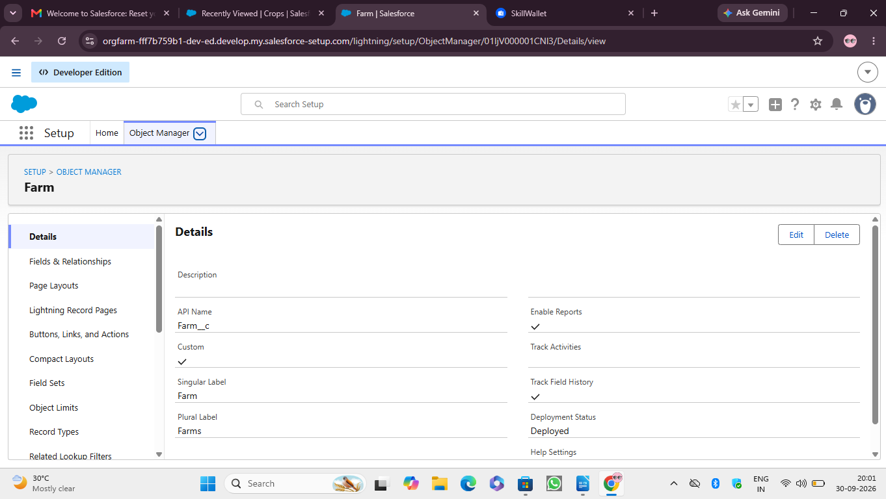
Leave everything else as is, and click Save.

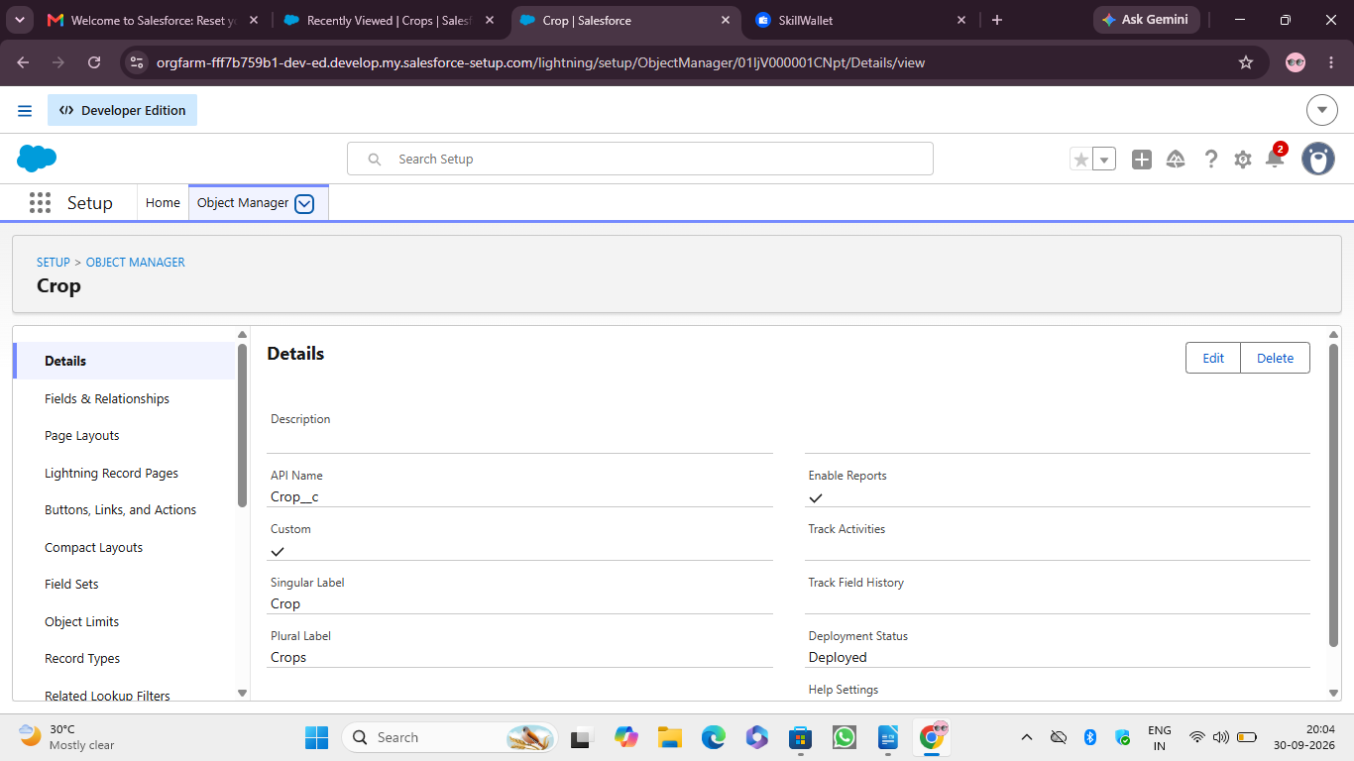
Activity 3 : Creation of Farmer object
StoryDuration: 10m
In Progress

Description
Click on the gear icon and then select Setup.
Click on the object manager tab just beside the home tab.
After the above steps, have a look on the extreme right you will find a Create Dropdown click on that and select Custom Object.
a. On the Custom Object Definition page, create the object as follows:
b. Label: Farmer
c. Plural Label: Farmers
d. Record Name: Farmer Name
e. Select the data type as "Text".
f. Check the Allow Reports checkbox.
g. Check the Allow Search checkbox.
h. In the Object Creation Options section, select Add Notes and Attachments related list to default page layout.
i. Click Save.
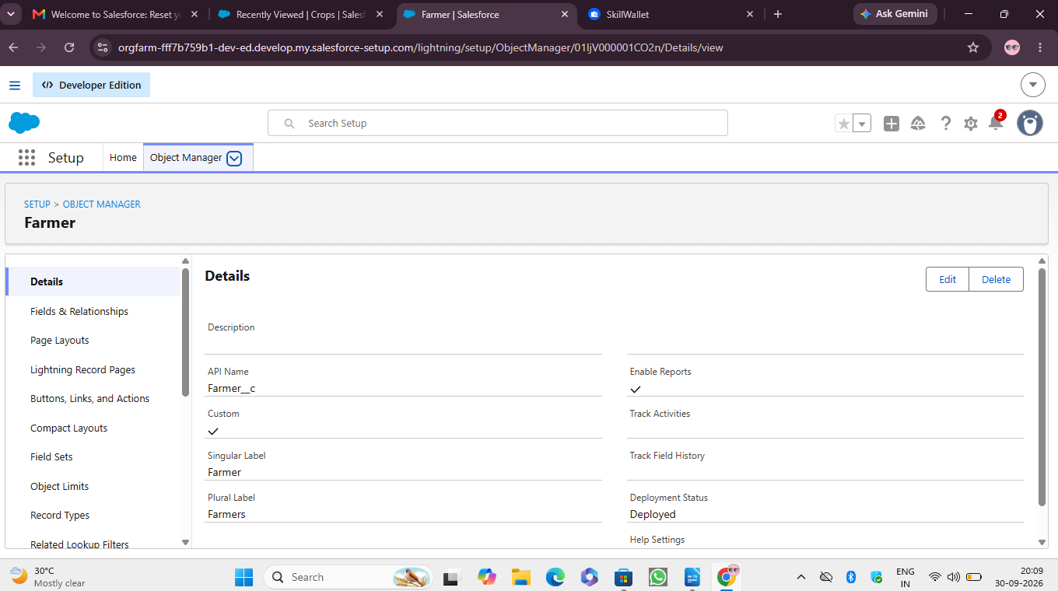
Activity 4:Creation of Buyer object
StoryDuration: 10m
In Progress

Description
Click on the gear icon and then select Setup.
Click on the object manager tab just beside the home tab.
After the above steps, have a look on the extreme right you will find a Create Dropdown click on that and select Custom Object. a. On the Custom Object Definition page, create the object as follows:
b. Label: Buyer
c. Plural Label: Buyers
d. Record Name: Buyer Name
e. Select the data type as "Text".
f. Check the Allow Reports checkbox.
g. Check the Allow Search checkbox.
h. In the Object Creation Options section, select Add Notes and Attachments related list to default page layout.
i. Click Save.

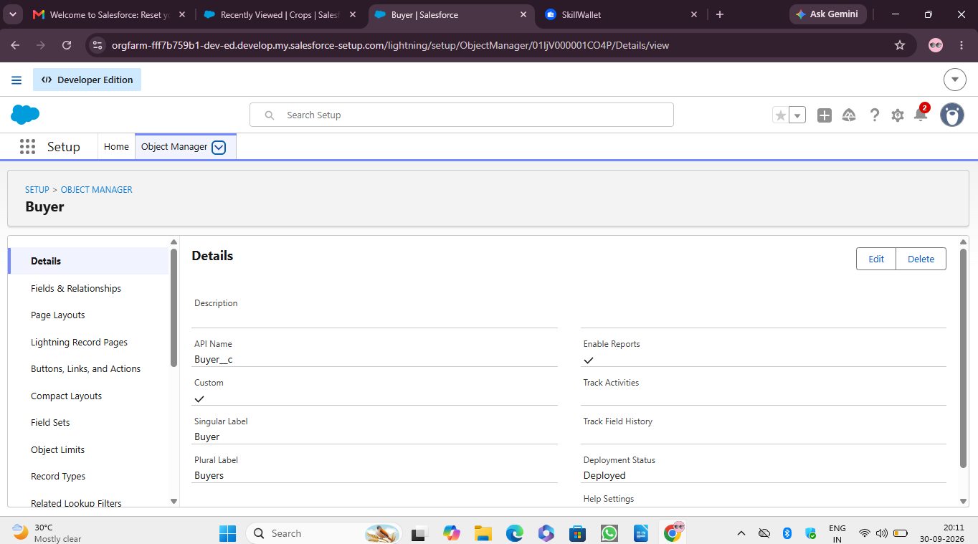

Description
Tabs in Salesforce help users view the information at a glance. It displays the data of objects and other web content in the application.

Activity 1: Creation of Farm tab
StoryDuration: 5m
In Progress

Description
Now create a custom tab.
1. Click on the Home tab, enter Tabs in Quick Find and select Tabs.
2. Under custom object tabs, click New.
3. For Object, select Farm.
4. For Tab Style, select any icon.
5. Leave all defaults as is. Click Next, Next, and Save.
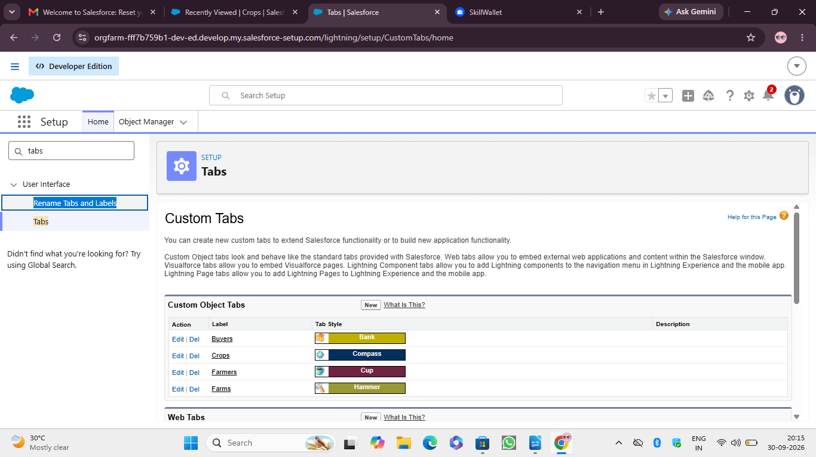
Activity 2:Creation of Crop tab
StoryDuration: 5m
In Progress

Description
Now create a custom tab.
Click on the Home tab, enter Tabs in Quick Find and select Tabs.
Under custom object tabs, click New.
For Object, select Crop.
For Tab Style, select any icon.
Leave all defaults as is. Click Next, Next, and Save.

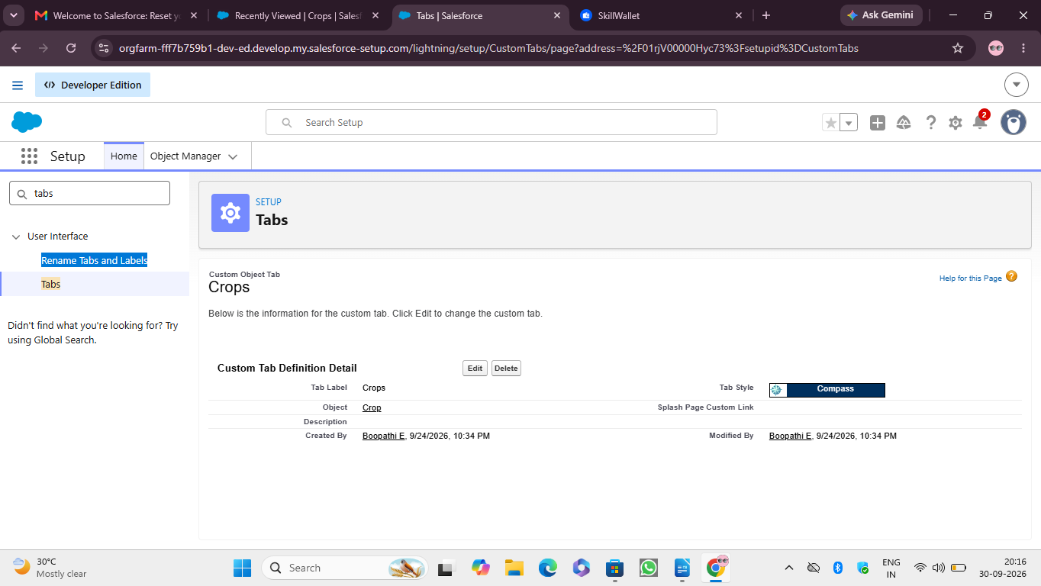

Activity 3:Creation of Farmer tab
StoryDuration: 5m
In Progress

Description
Now create a custom tab.
Click on the Home tab, enter Tabs in Quick Find and select Tabs.
Under custom object tabs, click New.
For Object, select Farmer.
For Tab Style, select any icon.
Leave all defaults as is. Click Next, Next, and Save.

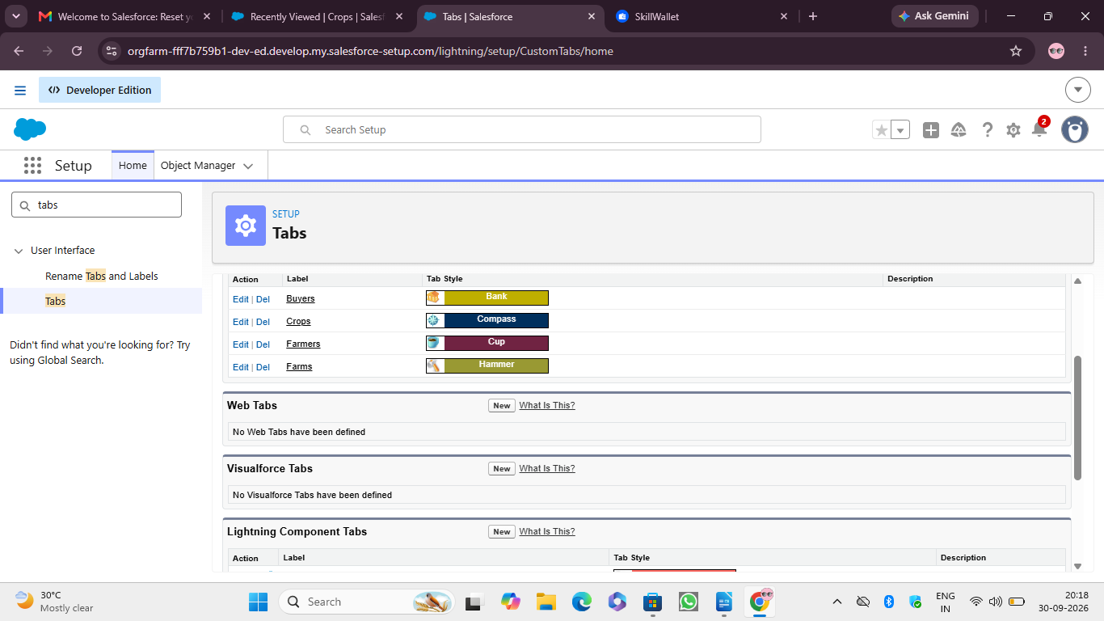
Activity 4:Creation of Buyer tab
StoryDuration: 5m
In Progress

Description
Now create a custom tab.
Click on the Home tab, enter Tabs in Quick Find and select Tabs.
Under custom object tabs, click New.
For Object, select Buyer
For Tab Style, select any icon.
Leave all defaults as is. Click Next, Next, and Save.
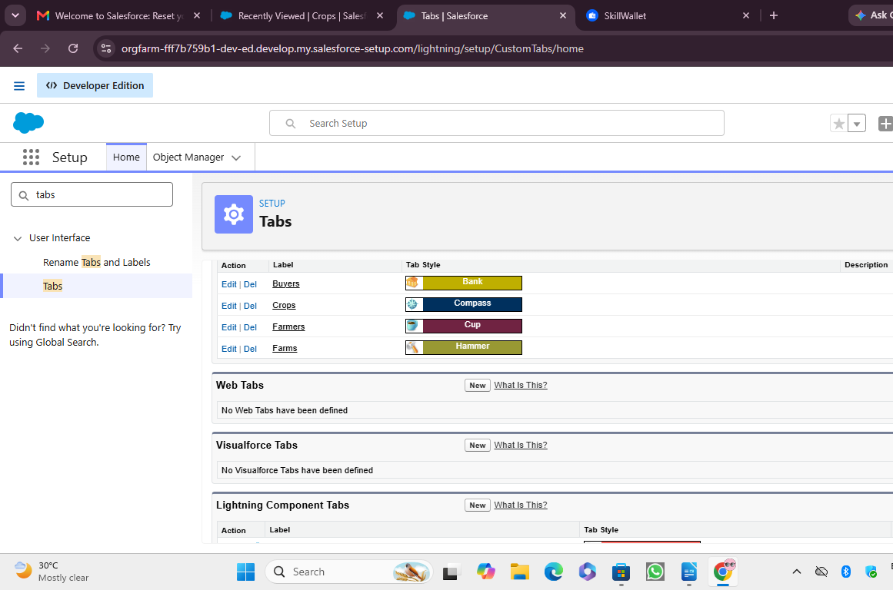

Activity 1: Create the Farm Management System app
StoryDuration: 2h 10m
In Progress

Description
● From Setup, enter App Manager in the Quick Find and select App Manager.
● Click New Lightning App. Farm Management System as the App Name, then click Next
Under App Options, leave the default selections and click Next.
● Under Utility Items, leave as is and click Next.
● From Available Items, select Farm, Crop, Farmer ,Buyer Reports ,and Dashboards and move them to Selected Items. Click Next.
● From Available Profiles, select System Administrator and move it to Selected Profiles. Click Save & Finish.
● To verify your changes, click the App Launcher, type Farm Management System and select the Job Application app.
Note :
App Launcher-Displays available apps.
App Name-Displays the current selected app.
3. Navigation menu-Displays the tabs available inside the app.

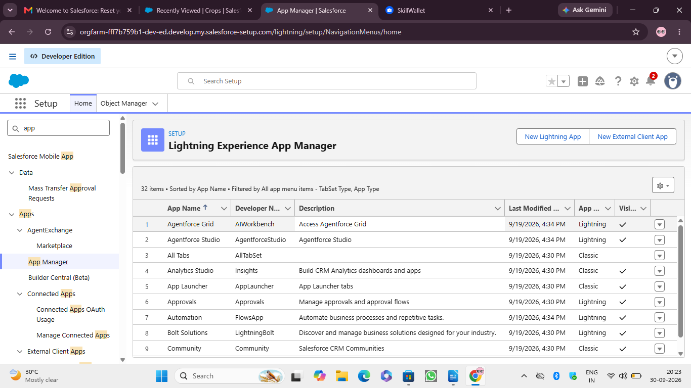
Activity 1:Creation of fields for the Farm objects
StoryDuration: 10m
In Progress

Description
click the gear icon and select Setup. This launches Setup in a new tab.
Click the Object Manager tab next to Home.
Select Farm.
Select Fields & Relationships from the left navigation, and click New
5.Choose Data type as a picklist ,Click next
6.Enter Field Label (Farm Type),and Enter Values as (Crop,Livestock,Mixed)
7.Next,Next Click Save.
Now let's create the other fields following Activity1 steps 1 to 4 and we must choose the data types of the fields carefully.
1.Next we Create another Picklist Field,Enter field label (Soil Quality) enter values (Organic,Cover Crops,Composting)
2.Again we Create Picklist field,Field Label (Irrigation type),
Enter Values (Sprinkler irrigation,Drip irrigation,localized irrigation)
3.Choose data type as a text,enter field label(Location)
4.Choose data type as text,enter field label (size)
5.Create a Master Detail relationShip with Farmer Object.
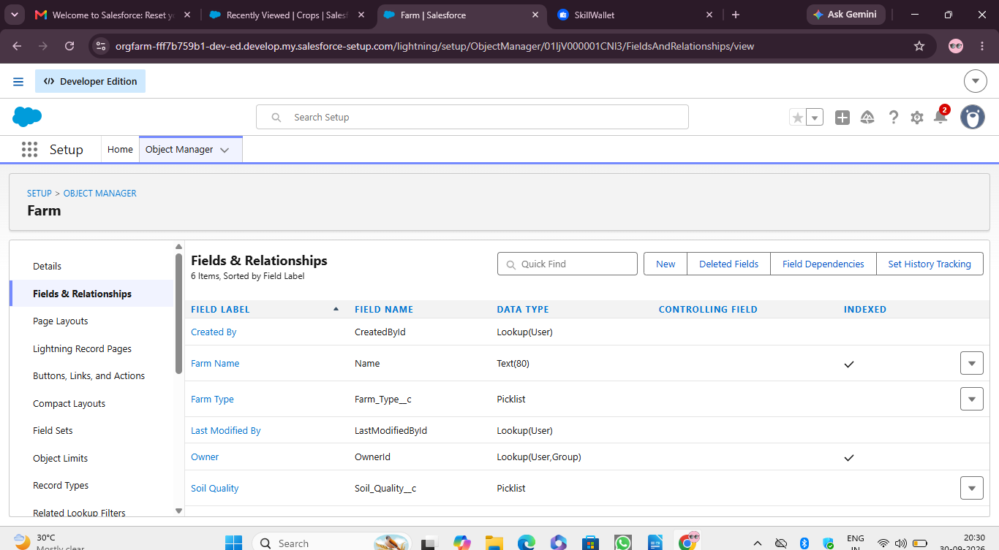

Activity 2: Creation of fields for the Crop objects
StoryDuration: 10m
In Progress

Description
1.Choose Data type As a text,Enter Field Label name (Crop Name),Next save.
2.Select Data type as date ,Enter Field label (Planting Date),then save .
3.Again we select data type as a date,Enter field label (Harvest date),save
4.Next We Create Lookup relationships on crop objects related to Farm Objects.
5.We select data type as currency,Enter field Label (Actual Yield), Next Save it.
6.Select Data type as a Number,enter Field Label (Total Acres Harvested),Enter Maximum Length(20) and save.
7.Now We create a Formula Field For That Select data Type As a Formula,Click Next.
8.Enter Field Label (Expected Yield per Acre),Select formula return type as Currency,click Next.
9.Enter a Formula Actual Yield Divide By Total Acre Harvested, then click next and save.

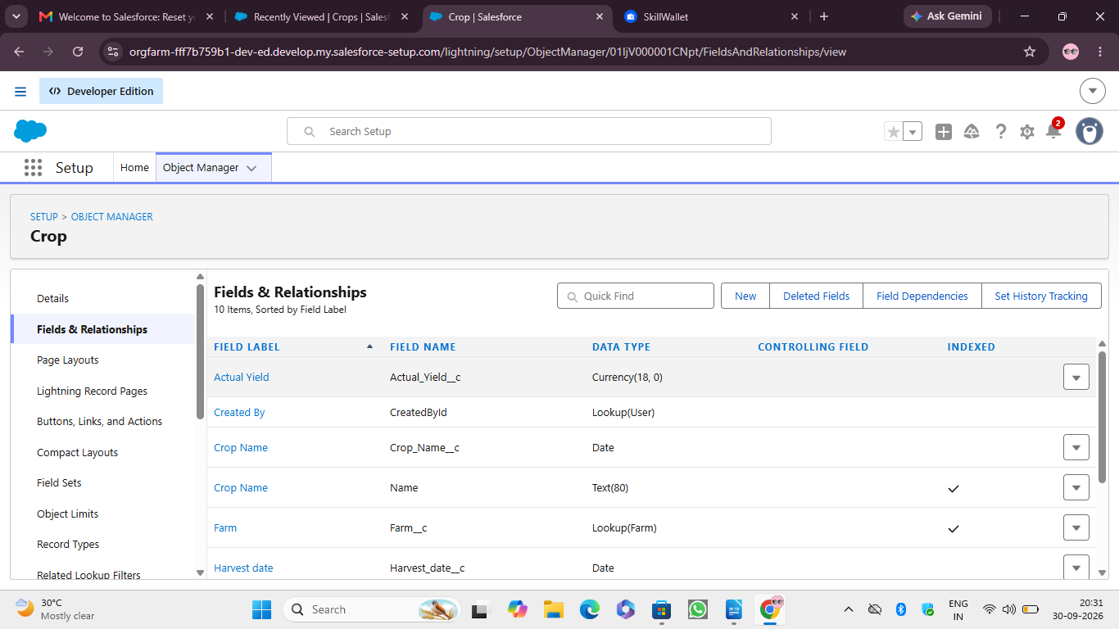
Activity 3: Creation of fields for the Farmer objects
StoryDuration: 10m
In Progress

Description
1.Select Data type Phone,Enter field label(Contact Number),next Save.
2.Select Data type Picklist,Enter Field Label(State),Enter values (Telangana,Andhra Pradesh,Tamilnadu),save.
3.Choose Data type Picklist,Enter Field Label (District),Enter Values of district,next save.
4.Again select Data type as Picklist,Enter Field Label (Village),Enter Values of villages,next save.
Creation of field dependency :
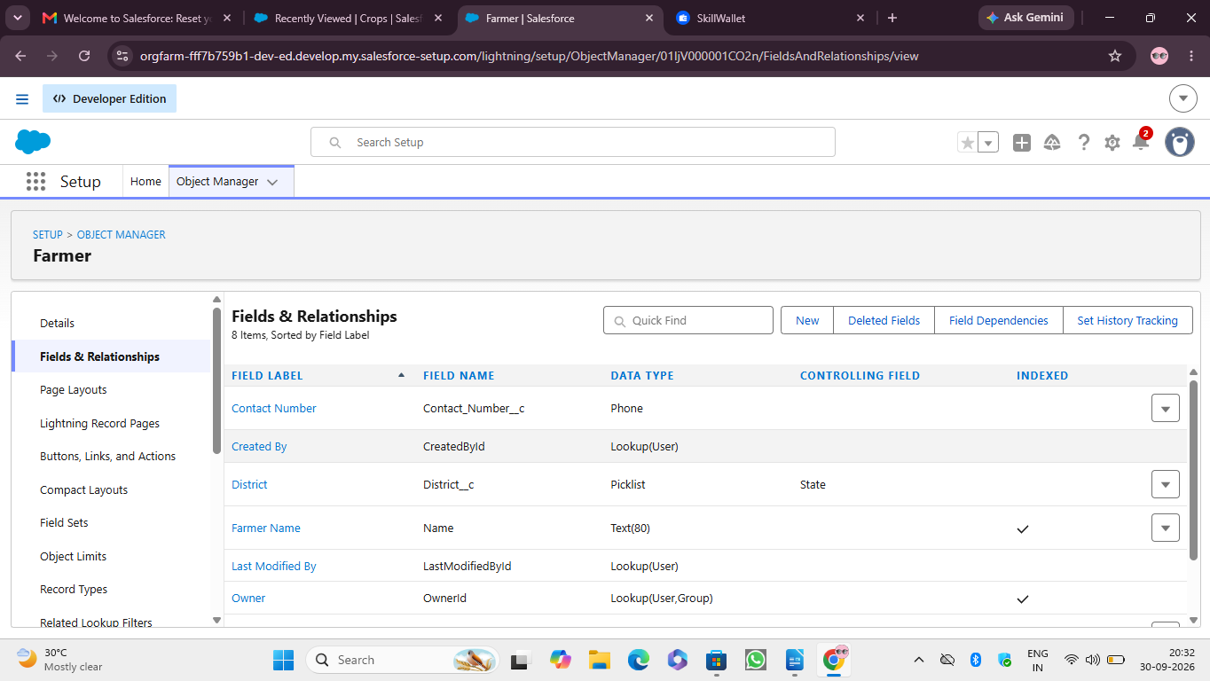
1.Now create Field Dependency For District field,Open Object Manager,Choose Farmer object ,select Fields&Relationships,On Right side We have Field Dependency option,select that option.
2.Click new, Select Controlling Field as State,Dependent Field As District,Click on Continue.
3.Select the appropriate Value in each column by double-clicking them.
4. For Ex. Telangana - Yadadri Bhongir.
5. Click Include Values. And it is also the same for Andhra Pradesh, Tamilnadu with its city.
6. Click Preview, then test the dependency by selecting a different State and viewing the associate Values available for Particular state.
7. Click Close to close the preview window, Click Save.

Activity 4: Creation of fields for the Buyer objects
StoryDuration: 10m
In Progress

Description
1.Select Data type as a Phone,Enter a Field Label(Contact),Save.
2.Select Data type as an Email,Enter Field Label(Email), Next save.
3.Select Data type Text area,Enter Field Label(Address),Save it.
4.Select Data type Picklist, Field Label(Buyer Type),Enter values (Wholesale,Retail),Click Save.

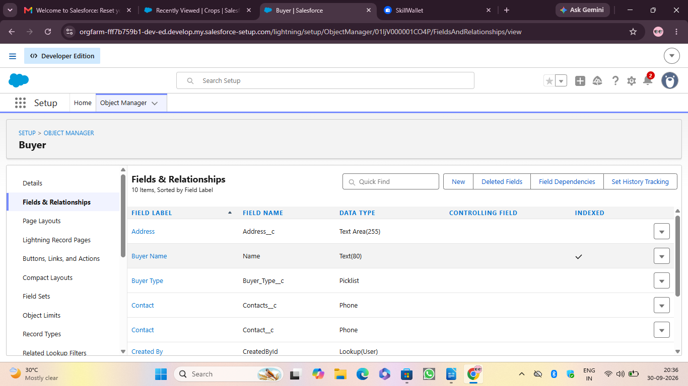
Activity 1: Create a custom profile
StoryDuration: 10m
In Progress

Description
From setup , enter profiles in Quick Find box
Select profiles (Standard user).
Click clone.
For Profile, enter the Sales Department.
5. Click save.

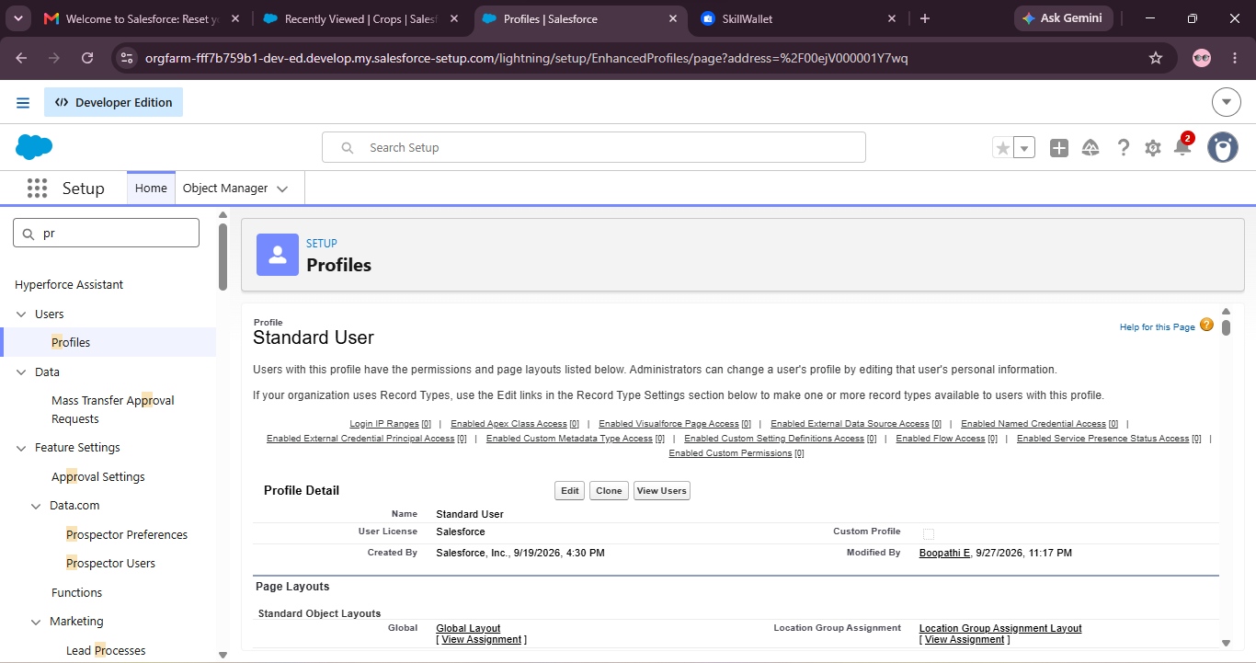
Create a profile with the profile name as “ Farm Manager” .
6. From setup , enter profiles in Quick Find box
7. Select profiles (Standard user).
8. Click clone.

Activity-1: Creation of role
StoryDuration: 10m
In Progress

Description
From the Quick find box search for the role and click on the roles option
select the set up roles option
3. Below the CEO click on add role and enter the label name as a ” Farm Manager ” and the role name will be Automatically populated and click on save.

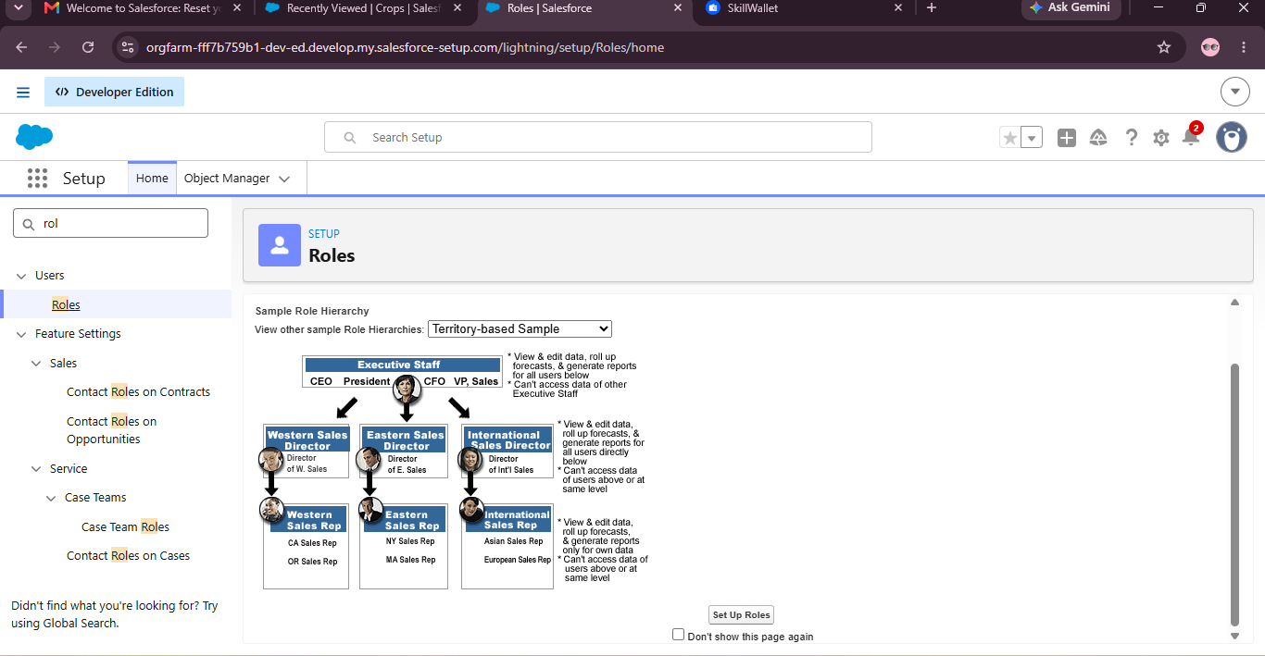
Activity 1: To Create a user
StoryDuration: 10m
In Progress

Description
From Setup, enter Users in the Quick Find box, then select Users.
Click New User.
Enter First name as Farm and last name as Manager.
Enter the user’s name and email address and a unique username in the form of an email address. By default, the username is the same as the email address.
Select role Farm Manager.
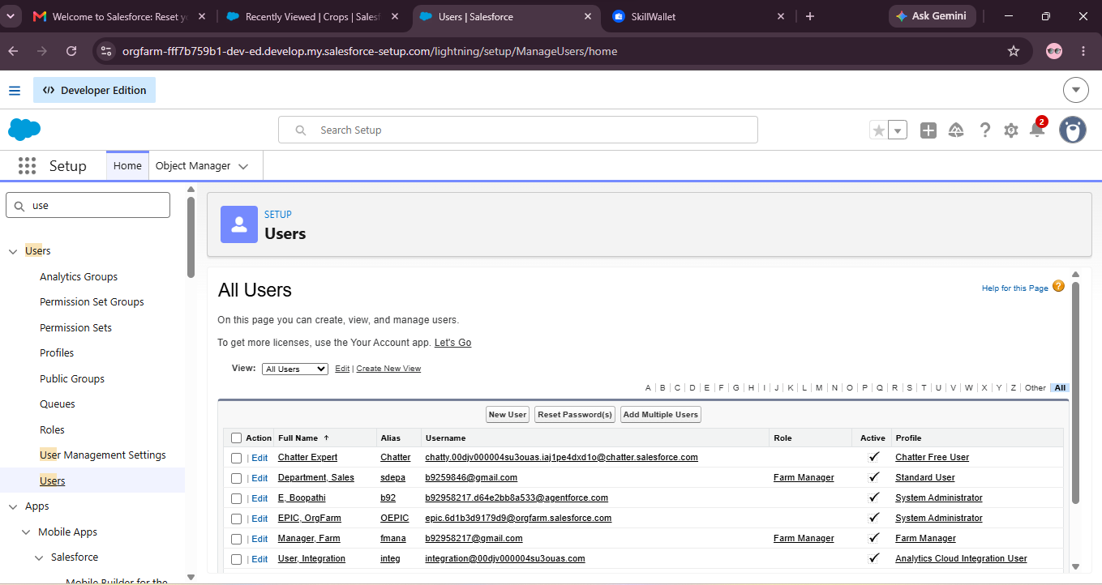
Select user License as Standard Platform User.
Select profile(Farm Manager).
Click save.
Create a user with a username as “Sales Department”, and assign him the sales Manager profile. Follow the steps from above Activity

Activity 1:Create a sharing rule
StoryDuration: 10m
In Progress

Description
1) Go to Sharing Settings, which can be found under the Quick Find section.
2) Scroll down and find the candidate object where a sharing rule needs to be added, and then click on New to create a new sharing rule.
3) Add the label of the sharing rule you want to make.
4) Select your rule type based on the criteria.
5) Select the field and immediately check the field from the Crop object.
6) Select the crop as equal and the value is True.
7) And in selecting the users to share with the section select roles and in that select Farm Manager.
8) And in the section of select the level of access for the users give the access Read/Write.
9) And save the rule.

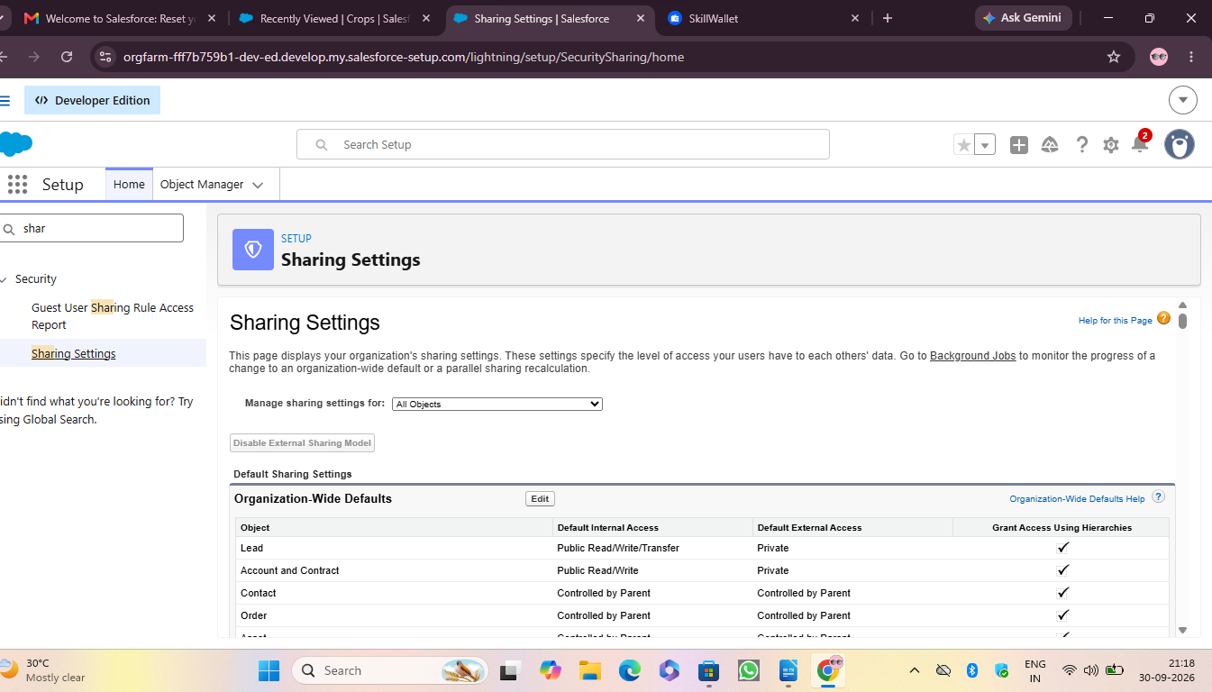
Activity 2:Create a Sharing Rule to Share the records of Buyer
StoryDuration: 10m
In Progress

Description
Create a Sharing Rule to Share the records of Buyer to Sales department with the Access of Read/Write.
Follow the steps from above Activity.

Activity 1:Create a Record(Farmer)
StoryDuration: 10m
In Progress

Description
● Click on App Launcher on the left side of the screen.
● Search Farm Management & click on it.
● Click on Farmer Tab.
● Click new and fill details & Save.
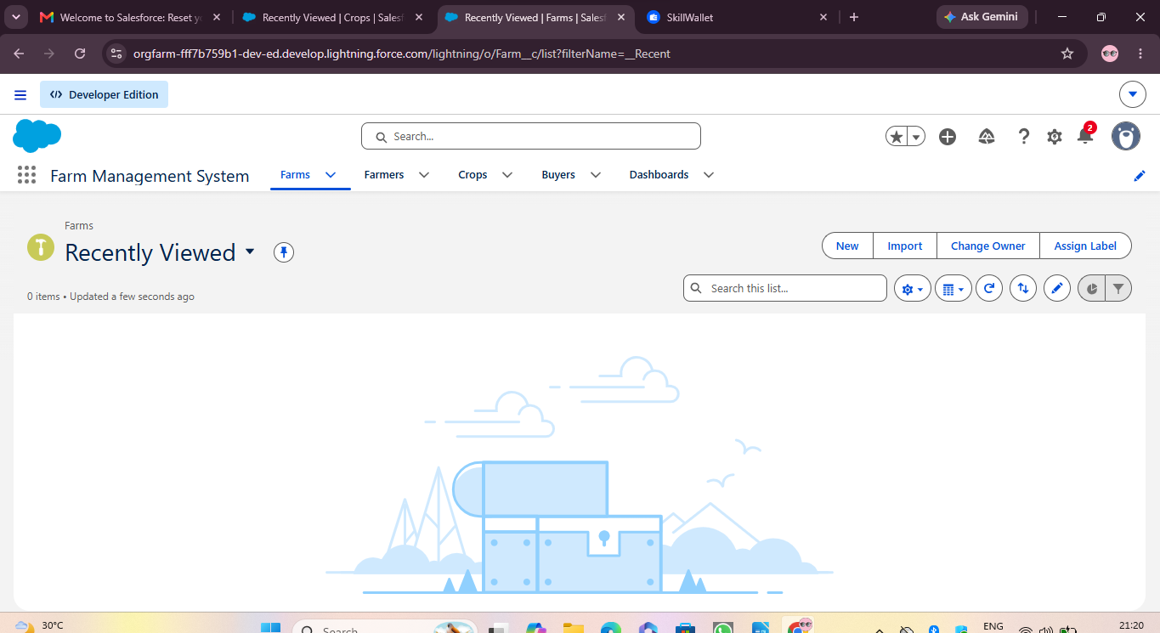

Activity 1:Create a report
StoryDuration: 10m
In Progress

Description
Create a report that displays the rating of the account and which has type and account name.
1) Click on app launcher search for reports.
2) Click on the new report and select the category as Farmer with Farms.
3) In the details section select the option start report.
4) In Outline Click on Column Select Which Field you want to display in the Report.
5) Click Group,Select Which Fields You Want to Group.
6) Save the report by giving the label name(Farmer with Farms) and save the folder as a public folder and save the report.

Activity 2:Create a Report using the Objects Crops, Buyers.

Description
StoryDuration: 10m
In Progress

Description
Create a Report using the Objects Crops, Buyers. Follow the steps from above Activity.

Activity 1 : Create a Dashboard
StoryDuration: 20m
In Progress

Description
Click the Dashboard tab.
Click New Dashboard.
Name the dashboard Farmers with farms and click Create.
Click +Component.
Select the Farmers with Farms and click Select.
Select the Gauge chart and click Add.
Click Save and then Done.

Activity 1 : Report
StoryDuration: 10m
In Progress
● Click on App Launcher on the left side of the screen.
● Search Farm Management System & click on it.
● Click on Reports Tab.
● Click on Farmers with Farms & see records

Activity 2: Dashboard
StoryDuration: 10m
In Progress

Description
• Click on App Launcher on the left side of the screen.
• Search Farm Management system & click on it.
• Click on Dashboard Tab.
• Click Farmers With farms & see records.

